Project Report (Startup Analysis)

INTRODUCTION

Overview

A startup is a company in the early stages of development that is set up by one or more several people to enter an existing market with unique products or services.

Starting a new company can be an exciting and rewarding experience, but it also requires careful planning and analysis to ensure that the business is viable and successful. There are several key areas that you should focus on when conducting a startup company analysis.

Purpose

Project startup is a very short phase of the project management cycle. It is a transition step between project planning and execution. It support and improve decision making.

It is also important to regularly review and update your analysis as the business progresses, in order to adapt to changing market conditions.

PROBLEM DEFINITION & DECISION MAKING

Empathy map 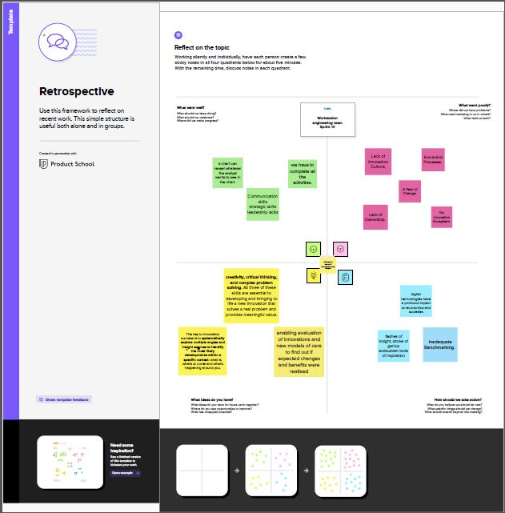

Brainstorm

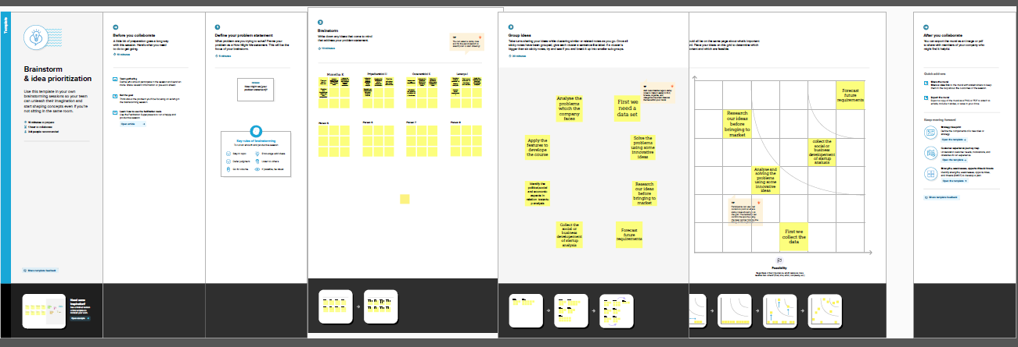

RESULT

Social Impact: Startups are the boost for any country. By analysing the startups and number of startups coming every year and industries that are seeing the boom, may somebody with the dilemma to start or not start can start his/her own company and become successful.

Business Model/Impact: Can make this visualization application available for people, for more insights and ideas can ask for payment and also can give these insights to investors and banks to make the understand and help in the sense of investing.

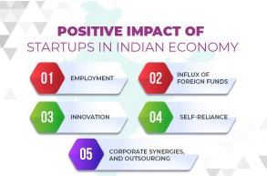

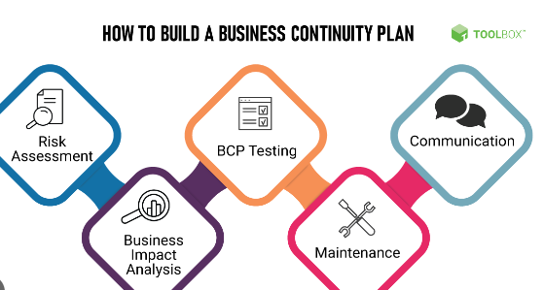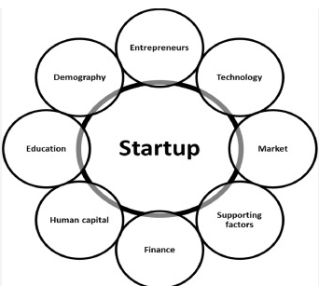

ADVANTAGES

The Indian government has introduced several startup tax incentives. These include a deduction of up to 100% on profits for the first three years and a tax holiday for the first year of operation.

* More opportunities to learn
* Flexible hours
* Unique experience

DISADVANTAGES

### Compensation

### Market access

### Team composition

### APPLICATIONS

### Business

### Health care

### Financial technology

### Consumer media

### CONCLUSION

### We conclude from this project the startup summary business plan includes the description of your product and services, the structure of your business, your target market and licensing requirements among others.

### FUTURE SCOPE

### Increase in globalization

### Startup ecosystem

### Make in India initiative

### APPENDIX

### Source code - Dashboard

### <div class='tableauPlaceholder' id='viz1682143037827' style='position: relative'><noscript><a href='#'><img alt='Dashboard 1 ' src='https:&#47;&#47;public.tableau.com&#47;static&#47;images&#47;Da&#47;Dashboard___16821349754590&#47;Dashboard1&#47;1_rss.png' style='border: none' /></a></noscript><object class='tableauViz' style='display:none;'><param name='host_url' value='https%3A%2F%2Fpublic.tableau.com%2F' /> <param name='embed_code_version' value='3' /> <param name='site_root' value='' /><param name='name' value='Dashboard___16821349754590&#47;Dashboard1' /><param name='tabs' value='no' /><param name='toolbar' value='yes' /><param name='static_image' value='https:&#47;&#47;public.tableau.com&#47;static&#47;images&#47;Da&#47;Dashboard___16821349754590&#47;Dashboard1&#47;1.png' /> <param name='animate_transition' value='yes' /><param name='display_static_image' value='yes' /><param name='display_spinner' value='yes' /><param name='display_overlay' value='yes' /><param name='display_count' value='yes' /><param name='language' value='en-US' /></object></div> <script type='text/javascript'> var divElement = document.getElementById('viz1682143037827'); var vizElement = divElement.getElementsByTagName('object')[0]; if ( divElement.offsetWidth > 800 ) { vizElement.style.width='100%';vizElement.style.height=(divElement.offsetWidth*0.75)+'px';} else if ( divElement.offsetWidth > 500 ) { vizElement.style.width='100%';vizElement.style.height=(divElement.offsetWidth*0.75)+'px';} else { vizElement.style.width='100%';vizElement.style.height='1227px';} var scriptElement = document.createElement('script'); scriptElement.src = 'https://public.tableau.com/javascripts/api/viz_v1.js'; vizElement.parentNode.insertBefore(scriptElement, vizElement); </script>

### Source code – story

### <div class='tableauPlaceholder' id='viz1682143214049' style='position: relative'><noscript><a href='#'><img alt='Story 1 ' src='https:&#47;&#47;public.tableau.com&#47;static&#47;images&#47;Bo&#47;Book2_16821357411430&#47;Story1&#47;1_rss.png' style='border: none' /></a></noscript><object class='tableauViz' style='display:none;'><param name='host_url' value='https%3A%2F%2Fpublic.tableau.com%2F' /> <param name='embed_code_version' value='3' /> <param name='site_root' value='' /><param name='name' value='Book2_16821357411430&#47;Story1' /><param name='tabs' value='no' /><param name='toolbar' value='yes' /><param name='static_image' value='https:&#47;&#47;public.tableau.com&#47;static&#47;images&#47;Bo&#47;Book2_16821357411430&#47;Story1&#47;1.png' /> <param name='animate_transition' value='yes' /><param name='display_static_image' value='yes' /><param name='display_spinner' value='yes' /><param name='display_overlay' value='yes' /><param name='display_count' value='yes' /><param name='language' value='en-US' /></object></div> <script type='text/javascript'> var divElement = document.getElementById('viz1682143214049'); var vizElement = divElement.getElementsByTagName('object')[0]; vizElement.style.width='100%';vizElement.style.height=(divElement.offsetWidth*0.75)+'px'; var scriptElement = document.createElement('script'); scriptElement.src = 'https://public.tableau.com/javascripts/api/viz_v1.js'; vizElement.parentNode.insertBefore(scriptElement, vizElement); </script>